Education 20/20 Inc.

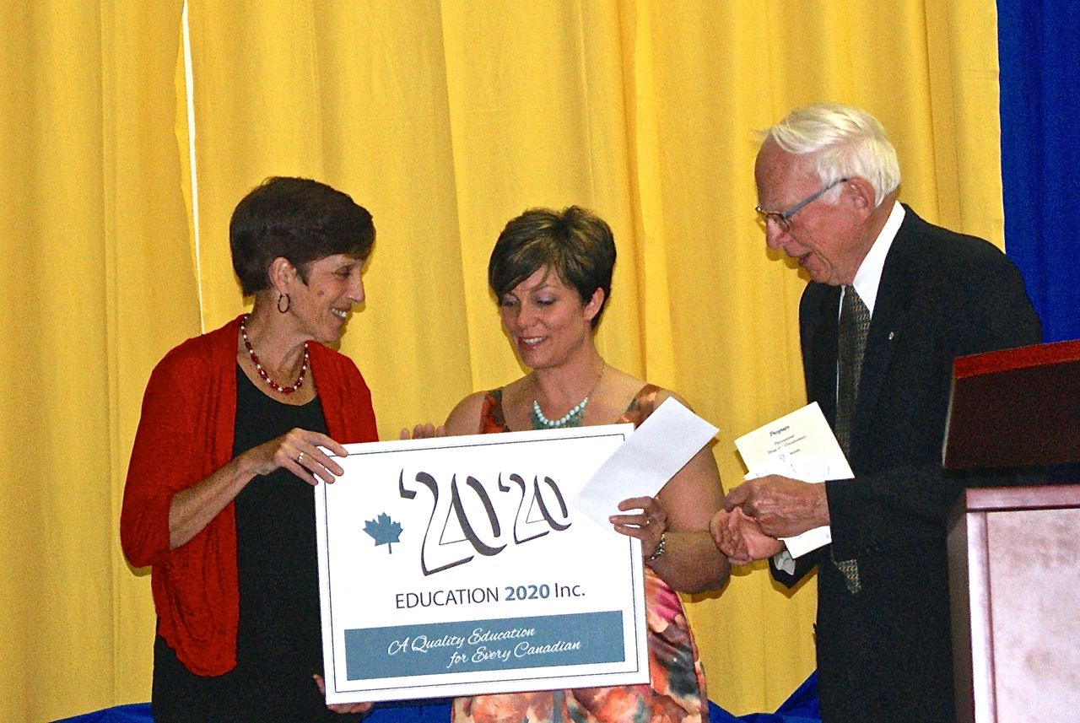
2014 Excellence Award in education presented to
Kinkora Regional High School

A quality education system is one where:
- Learners are healthy
- Environments are safe and respectful
- Content is relevant
- Outcomes are linked to personal and community objectives
- Support is focused on learners and learning.
- Information and advice is timely and independent
- Teachers are professional, autonomous and accountable

Education 20/20 Inc.
101 Kent St., PO Box 624/rue Kent, BP 624
Charlottetown, PEI C1A 1M0 Canada
Tel: 902-892-2060

Education 20/20 Inc.

Education 20/20 Inc. is an independent, broad based, national, not-for-profit education organization, located in Charlottetown, PEI and is governed by a volunteer Board of Directors.

Vision: A quality education for every Canadian.

Mission: To support and strengthen a culture of learning for all Canadians.

Mandate: To contribute to the education of our citizens by providing information, encouragement and support for a quality education for all citizens.

Activities:
- Monthly electronic newsletter
- Website
- Occasional papers
- Workshops

Directors:
- Don Glendenning, President
- Bill Whelan, Vice President
- Alice Taylor, SecretaryTreasurer
- Brenda Goodine
- Tanya Craig
- Tim McRoberts
- Tom White-Hassler
- Maureen Kerr
- Katherine McQuaid

